The Liberation War of 1971 began with the Language Movement of 1952

The Liberation War of 1971 and the Language Movement of 1952 are closely linked, as both highlight the Bengali people's struggle for their cultural, linguistic, and political rights. The Language Movement was the first significant pushback against West Pakistan's control and laid the groundwork for the independence movement.
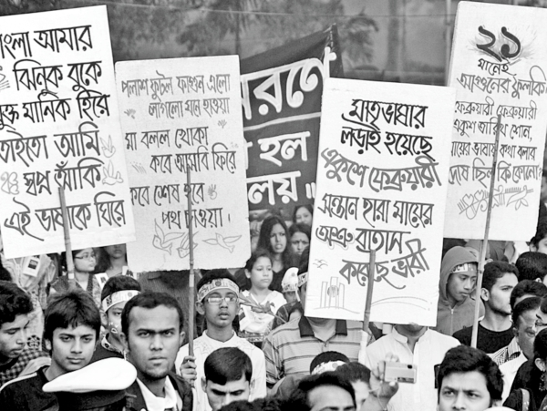
The issue started in 1948 when the Pakistani government announced that Urdu would be the only state language, ignoring the fact that over 56% of East Pakistan's population spoke Bengali. This decision led to widespread protests in East Pakistan. The call for Bengali to be recognized as a state language grew stronger over time, reaching a peak on February 21, 1952, when police shot at peaceful demonstrators in Dhaka, killing several students, including Salam, Rafiq, Barkat, and Jabbar. Their deaths turned February 21 into a symbol of resistance and unity, now celebrated as International Mother Language Day.
The Language Movement was not just about language rights; it reflected the increasing frustration with West Pakistan's exploitation and neglect of East Pakistan. Economic inequality, political exclusion, and cultural oppression further distanced the Bengalis. Despite contributing more than half of Pakistan's GDP, East Pakistan received only a small share of the national budget, intensifying discontent. Cultural repression, including restrictions on Bengali literature, music, and traditions, also fueled anger. Initiatives like the Six-Point Program in 1966, led by Sheikh Mujibur Rahman, called for greater autonomy and self-governance.

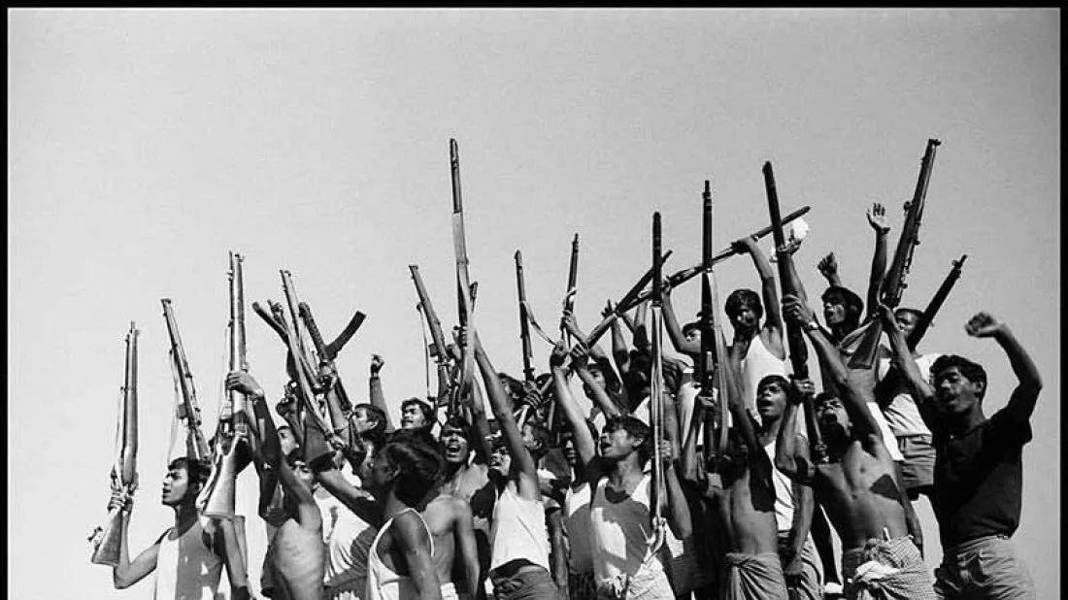
The political turmoil of 1970, when the Awami League won the majority in Pakistan's elections but was denied power, marked a turning point. On March 7, 1971, Sheikh Mujibur Rahman's famous speech in Dhaka urged people to resist, leading to the Liberation War that began on March 26.
In summary, the Liberation War of 1971 was deeply influenced by the Language Movement of 1952, which ignited the Bengali people's sense of identity, unity, and resolve to gain independence.

